# Week 05: Instructor Notes

## Overview

Testing is an integral part of the Quality Assurance process, so much so that many companies confuse the difference between the two. Students will understand the differences between QA and Testing.

## Objectives

By the end of the week, each student will be able to:

* Measure Quality, Maturity, Process Improvement, Root Cause and Measurement with regards to Testing

### Partnership/Group work:

* No partnership or group work is specified, but students can work together and turn in individual assignments.

## Looking Ahead

Next week's announcements:

* Please create and post your Announcement for W06 by Friday of this week.

# Prepare

## Overview

Testing software code, Testing is valuable in producing quality products, providing maturity of the development process, and determining root causes in error detection. The same principles found in software testing can transfer elsewhere in software engineering. Distinguishing between Testing and Quality Assurance (QA) and supporting each other is vital in producing reliable code. This week is a preview to QA.

## Objectives

By the end of the week, each student will be able to:

* Measure Quality, Maturity, Process Improvement, Root Cause and Measurement with regards to Testing

## Preparation Material

To be prepared for this module's activities, please read the following and be prepared to start or complete activities for Teach One Another and Prove assignments.

### Reading

* See [Reading Materials](../Reading/Reading.html)

As you read, try to answer the following questions:

* QA vs. Testing Summary
  + Define Quality Assurance.
  + What is the difference between QA and Testing?
  + How are they similar and different?
  + Provide an example of each?
* QA Models Summary
  + What is a QA Model?
  + Based on the characteristics of a model, where would one use the model?
* Capability Maturity Model Summary
  + What is CMM? Why is it important? What is an immature project vs. a mature
  + What are the different levels? What are their purposes?
  + What is the difference between Project, Company, and Organization levels?

"Quality" is a relative term. It means different things in different contexts. What is quality for a mobile game (Entertaining) might not be the same for an ATM machine (Secure, Reliable). The first step in any Q/A process is to precisely define the quality of the product.

Quality Characteristics and Models are developed and created using bottom-up design when developing requirements. In order to understand the difference of top-down design and bottom-up design, let’s talk a little about top-down. Top-down design is the process of taking a solution, like an idea for a program and breaking it down into smaller components, and then breaking those components down until they can be defined as functional requirements (what the product will do). Quality Characteristics and Models, or non-functional requirements work the other way, bottom-up. We identify a set of quality characteristics that describe, or we want for the product. The reading provides a good comprehensive list of 48+ characteristics, there are more. Once you have a list, you can categorize the characteristics or put them into groups, and label the group. Some of those groups can be group, and now you have a hierarchy of characteristics, much like the models you see in the reading. This is bottom-up design.

You can probably see that trying to do top-down design of quality characteristics would be a bit difficult, as you would not know where to start. Likewise doing a bottom-up design of functional requirements, would have the same problem, not knowing where to start.

## Part 1: Determining Non-Functional Requirements

You will need to pick a feature of your phone that you would like to test. The camera is out, as we did that exercise in week 02. I would recommend you use a feature that you can use the diagnosis application you downloaded.

You will then identify a quality characteristic, "[Software Quality Models](http://airccse.org/journal/ijsea/papers/5614ijsea03.pdf)" article as your guide that you will use to test the chosen feature.

* How would you measure the characteristic? Nominal, Ordinal, Interval, or Ratio scale.
* How accurate must it be?
* What type of inputs does it need?
* What type of conditions (environmental, internal state, non-human instrument, etc) might affect the measurement?

These questions and ones like it will be difficult to answer. You will need to think deeply about how you use your phone and about the needs of the applications you use. You will also need to conduct some research as to standards pertaining to the touch screen.

Once you have finished researching your quality characteristics, write a requirement, story or purpose for testing your requirement.

When you are finished, you and your partner(s) need to have a list of the quality requirements for the touch screen. Each one must be categorized by the aforementioned article's quality metrics. Each one must also be stated in such a way that it is unambiguous if a given touch screen meets the quality requirements. Please cite any resources that helped you arrive at the requirement (besides the reading, find at least one more).

For example, one quality requirement may read: "Reliability: The touch screen must function at 100% capacity between 0°C and 35°C ([Interelectronix](https://www.interelectronix.com/touch-screen-extended-temperature.html))"

You should have at least five requirements.

## Part 2: Create Test Cases

Based on what we previously learned about testing techniques, generate at least one test for each requirement. Each of these tests can be performed manually with your phone, or with the sensor app you installed on your phone earlier in the week.

Each test must consist of the following components:

1. **Name**: The name of the test.
2. **Quality Requirement**: The name of the quality requirement this test is meant to verify.
3. **Steps**: The steps one must perform to carry out the test. These steps must be precise, so anyone can conduct the test the way you envision. Remember to use the Action/Result or Action/Verify pattern.
4. **Outcome**: What is the expected outcome? What should the person conducting the test look for?

For example, here is a test written for Internships:

* **Purpose**: How to register for the internship class
* **Requirements**: Students shall request approval for a job in order to register for CSE 398
* **Story**: As a student, I want my internship job to be approved so that I can register for CSE 398 Internship
* **Pre-conditions**:
  + Web Browser with connection to byui.edu
  + An identical request has not been made.
* **Steps**
  + **Action**: Log into iPlan.byui.edu
    - **Results**: Browser is open with a web page
  + **Action**: Click on the Internship Approval panel link
    - **Results**: The internship Approval page shows up
  + **Action**: Click on the “Create an Internship Request” link
    - **Results**: The internship Registration Information page appears
  + …
  + **Action**: Look over the form to see that you have to fill out all of the required fields, then press the Submit button.
    - **Verify**: Form is submitted and shows up on the Internship Approval page
  + …
  + **Action**: In two days, check back to see if the request has been approved.
    - **Verify**: When the time for registration occurs, it is possible to register for CSE 398

**Submission**

Your team will submit one document here. The document must be in PDF format and professionally formatted. A professionally-formatted document includes but is not limited to:

* Free of spelling and grammatical errors.
* The information in the document is well organized.
* Everything is in the third person; no "I"s or "you"s.
* Character and paragraph formatting is intentional and consistent across the document.

Note: We have had some comments that this is the students making up the content of the course. At the surface, it can be perceived that way. This is one of many teaching techniques found in Bloom’s taxonomy, teaching methods found here at BYU-Idaho, and part of our learning model. The research and presentation are the summarization (Blooms level 5) of the content. The quiz questions and quiz are the assessment portion the assignment.

# Lab 05 - Measuring Sensors

## Overview

As a part of [Dr. Mobile](https://byui-cse.github.io/cse270-course/Labs/DrMobil.html)'s development, engineers and programmers need to know how accurate the sensors, both internal and external, to determine the noise to signal ratio in calibrating and detecting a change to raise event update to the software.

You will need a mobile device to complete this lab or use pre-scanned lab data.

Depending on your phone type, you can:

* Activate the hidden hardware diagnose program.
  + From Phone keypad type: *#0*#
  + Look up your phone type
  + What does it look like:  
    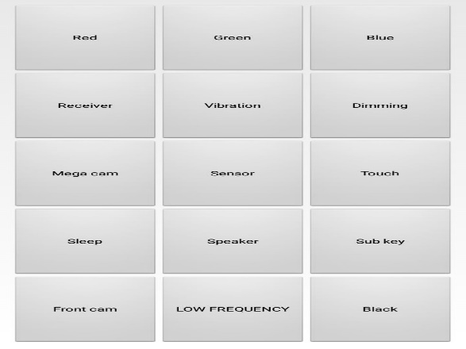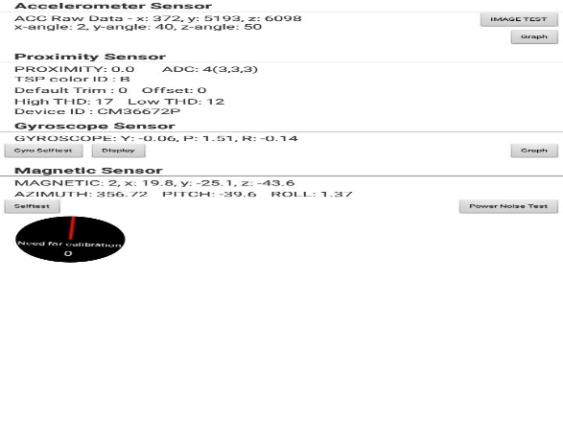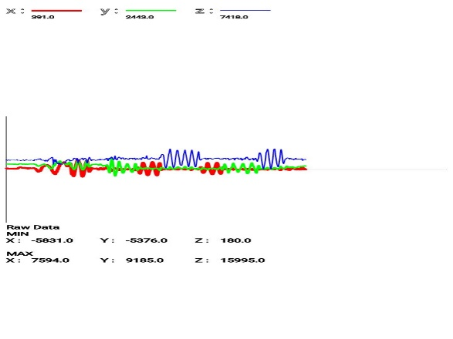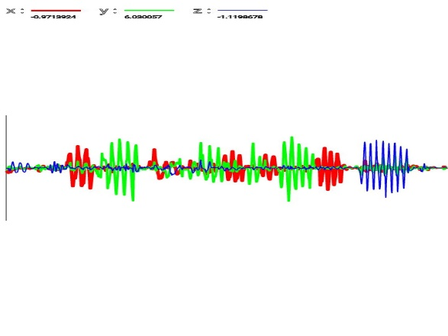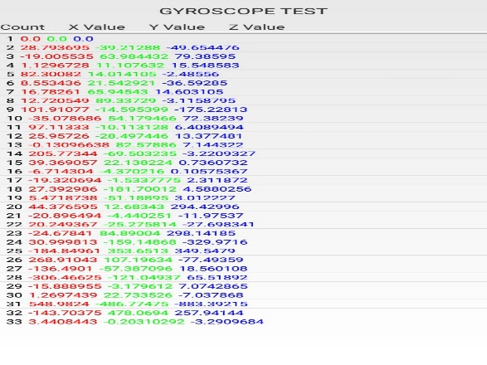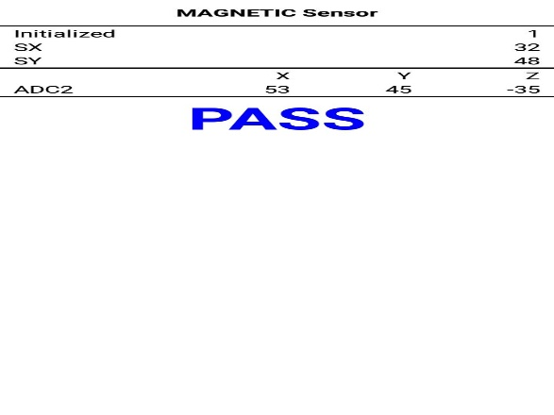
* Download a sensor app that will show the different sensor available on your phone
  + Android: Google Play: Sensor Lab or Phone Check and Test
  + iOS: Phone Diagnostics
  + Both: TestM (warning likes facebook info)
* Use any application where you can watch the sensor output. (Be creative). If you want, you could use your laptop or computer sensors. i.e., Windows Voice recorder.

## Assignment

Complete the following steps:

### Observe SENSOR

Record the program that you are using for this lab.

Pick a sensor, observe the output of the device at rest. Interact with the sensor.

Answer the following questions:

* What is it measuring?
* Determine the normal sensory?
* Determine abnormal, change, or detection state? What caused it?

### Create Three Scenarios

Come up with three different ways, activities, or scenarios that you would use the sensor. For example, using the Accelerometer: Sitting, Walking, Running, Riding).

Answer the following questions:

* Determine the measurement criteria, write them down.
* Write down your prediction of what will happen during the activity.
* What are some risks? What side effects could happen?
* What would be considered a successful pass of your scenario? What would be an almost? And not quite?

### Test SCENARIOS

Using your observer sensor, test the device in your three scenarios.   
Record the results.

* Repeat your scenario until you get all successes.
* Repeat your scenario until you get the almost successes
* Repeat your scenario for not entirely.

Answer the following questions:

Did you have to change the test, your expectation, or the technique?

### SUMMARY

Do the following:

* Write an overview of what you learned.
  + Include what you used to test the sensor you are testing (What software)
  + Include your scenarios and how you tried it
  + Include what you determined was successful and what was not.
  + Include data or proof that you completed the test: measurements, screen captured, etc
* Post your write-up.

### Peer Testing

Read over two of your classmates' scenario summaries. Run the tests as they described them.

Answer the following in a reply post:

* Did you get the same results as your classmate?
  + If you didn't, what was the difference?
  + If you did, what could be improved?
* Suggest another scenario to test. Provide predictions as to the results.

## Submission

Post your summary to the discussion board.

Find two of your classmate's tests and run them. Post your results (with data).

You will be reporting your results in your Ponder assignment. Make sure you record your Lab points.

## Rubric

Use the following rubric to help understand the expectation.

|  |  |  |  |  |  |
| --- | --- | --- | --- | --- | --- |
|  | **Exceptional 100%** | **Good 90%** | **Acceptable 70%** | **Developing 50%** | **Missing 0%** |
| **Assignment 70%** | Summary | Test Scenarios | 3 Scenarios | Observation of Sensor | No original post |
| **Reply 20%** | 1st & 2nd Reply Peer Testing with answers to questions | 1st Peer Testing 1 with the answers to questions and   2nd ReplyPeer Testing 2 | 1st Reply Peer Testing 1 with the answers to questions or   2nd Reply Peer Testing 2 | 1st Reply Peer Testing 1 | No Reply |
| **Professionalism 10%** | The paper is easy to read and communicated. | Properly cited, there are no grammar or spelling errors, and the writing style is "professional." | Found an instance of a spelling error, grammar error, incomplete citation, overly verbose wording, poor formatting, or poor writing. | A citation is missing where one is needed (plagiarism alert!). | Gross spelling/grammar errors or other aspects of the writing that make the paper difficult to read. |

# Prove: Testing Quality Assurance Characteristics

## Overview

Apply QA Characteristics to Testing.

## Backstory

As part of determining the requirements for [Dr. Mobile](https://byui-cse.github.io/cse270-course/Labs/DrMobil.html), a committee of members from your test team has come up with a list of software test elements. You will be organized into groups of 2-4 to determine specific quality characteristics that prioritize and measure. You are a member of one of those teams, along with your partner(s).

## Instruction

Complete the following steps:

### Pick Software Elements

Pick three of the following software elements.

* Front-End Modules: [Dr. Mobile](https://byui-cse.github.io/cse270-course/Labs/DrMobil.html)'s user interface
* Back-End Modules on the Device: [Dr. Mobile](https://byui-cse.github.io/cse270-course/Labs/DrMobil.html) maintains multiple service jobs maintaining sensors, connectivity, and monitoring
* Back-End Modules outside the device: [Dr. Mobile](https://byui-cse.github.io/cse270-course/Labs/DrMobil.html) receives and transmits multiple connectivities with external resources
* Database in the Device: [Dr. Mobile](https://byui-cse.github.io/cse270-course/Labs/DrMobil.html) needs to store information at rest between transmission downtime.
* Database out of the Device: [Dr. Mobile](https://byui-cse.github.io/cse270-course/Labs/DrMobil.html) transmits large amounts of data back to the main office to store for later processing and retrieval.
* Security: Most of the information collected, used, and transmitted by [Dr. Mobile](https://byui-cse.github.io/cse270-course/Labs/DrMobil.html) has some confidentiality and security needs.
* Algorithms: [Dr. Mobile](https://byui-cse.github.io/cse270-course/Labs/DrMobil.html)'s competent that handles the processing information
* Component: Pick any feature of [Dr. Mobile](https://byui-cse.github.io/cse270-course/Labs/DrMobil.html)

### Quality Characteristics

For each element, select three quality characteristics to measure that element.

All three quality characteristics need to be different for each element, including nine other quality characteristics.

### Method of Measurement

Determine how to measure and then test characteristics for each element.  
For all nine quality characteristics, determine (1) how to measure the element and (2) how to capture data to satisfy a customer. Define the characteristic, identify either quantitative values (measured) or qualitative ranges (rated), and expected value.

### Conclusion

For each Software, Elements write a plan on how the quality characteristics will be tested

## Make it your Own

The completion of the core of this assignment is 89%. The assignment needs additional personalized work to achieve 100%.

Scripture Scenario: Pick one story, parable, or teaching from the scriptures that you could apply its quality principle from the scriptures.

Choose three Quality Characteristics or more and apply them to a gospel principle.

Identify the Characteristic or Principle in the story and explain how it could be measured or rated.

## Submission

Make sure that you upload a copy of your document to iLearn.

## Rubric

Use the following rubric to help understand the expectation.

|  |  |  |  |  |  |
| --- | --- | --- | --- | --- | --- |
|  | **Exceptional 100%** | **Good 90%** | **Acceptable 70%** | **Developing 50%** | **Missing 0%** |
| **QA-Testing Characteristics Tests 80%** | Make it your own | Method of Measurements and Test | It contains all three elements and nine quality characteristics | Has two or more significant issues | No answers to questions |
| **Professionalism 10%** | Make it your own | Properly cited, there are no grammar or spelling errors, and the writing style is "professional." | Found an instance of a spelling error, grammar error, incomplete citation, overly verbose wording, poor formatting, or poor writing. | A citation is missing where one is needed (plagiarism alert!). | Gross spelling/grammar errors or other aspects of the writing that make the paper difficult to read. |
| **Citations 10%** | One of the citations is a primary source | Additional 3-4 citations. | Contains 1-2 more citations other than the reading | Includes quotations from the reading | No Citations |